**Central Healthcare System**

*Submitted in partial fulfillment of the requirements for the degree of*

**Bachelor of Technology**

in

**Computer Science and Engineering**

*by*

**Raghav Jindal**

**18BCE2080**

**Nimish Batra**

**18BCE2087**

**Under the guidance of**

**Dr Balasubramanian V**

**SCOPE**

**VIT, Vellore.**

# 

**May, 2022**

**DECLARATION**

# 

We hereby declare that the thesis entitled **“Central Healthcare System”** submitted by me, for the award of the degree of *Bachelor of Technology in Computer Science and Engineering* to VIT is a record of bonafide work carried out by me under the supervision of Dr. Balasubramanian V.

We further declare that the work reported in this thesis has not been submitted and will not be submitted, either in part or in full, for the award of any other degree or diploma in this institute or any other institute or university.

# 

# 

# 

# 

Place : Vellore

Date : 30/05/2022

**Signature of the Candidate Signature of the Candidate**

**(Raghav Jindal) (Nimish Batra)**

**CERTIFICATE**

This is to certify that the thesis entitled "**Central Healthcare system**" submitted by **Raghav Jindal (18BCE2080), SCOPE**, VIT, and **Nimish Batra(18BCE2087), SCOPE,** VIT for the award of the degree of *Bachelor of Technology in Computer Science and Engineering*, is a record of bonafide work carried out by them under my supervision during the period, 02. 02. 2022 to 03.06.2022, as per the VIT code of academic and research ethics.

The contents of this report have not been submitted and will not be submitted either in part or in full, for the award of any other degree or diploma in this institute or any other institute or university. The thesis fulfils the requirements and regulations of the University and in my opinion meets the necessary standards for submission.

Place: Vellore

Date: **Signature of the Guide**

**Internal Examiner External Examiner**

**Head of the Department Programme**

# ACKNOWLEDGEMENTS

I would like to express my gratitude to Dr. G. Viswanathan, Mr. G V Selvam, SCOPE, for providing an environment to work in and for his inspiration during the tenure of the course.

In jubilant mood I express ingeniously my whole-hearted thanks to Dr, S Vairamuthu, Head of Dept, SCOPE, my guide and mentor Dr. Balasubramanian V, and all teaching staff and members working as limbs of our university for their not-self-centred enthusiasm coupled with timely encouragements showered on me with zeal, which prompted the acquirement of the requisite knowledge to finalise my course study successfully.It has been our privilege to have a team of project guides who have assisted us from the commencement of this project. The success of this project is a result of sheer hard work, and determination put in by us with the help of our project guide. His wisdom, knowledge, and commitment to the highest standards inspired and motivated us. Without his insight, support, and energy, this project wouldn't have kick-started and neither would have reached fruitfulness.

It is indeed a pleasure to thank my friends who persuaded and encouraged me always. At last but not least, I express my gratitude and appreciation to all those who have helped me directly or indirectly toward the successful completion of this project.

Place: Vellore

**Signature of the Candidate Signature of the Candidate**

**(Raghav Jindal) (Nimish Batra)**

# Executive Summary

Due to the rapid increase in population and because of people’s unhealthy lifestyle which includes lack of sleep, improper nutrition etc, the number of patients have been increasing by the day due to which all the hospitals are flooded and have low availability at times. Recently a lot of hospitals have been running out of beds which was majorly seen during the covid pandemic peak also. Thus we propose a Central healthcare system aimed to provide premier superior quality services. We propose a method to solve the crisis of an emergency remote system and unavailability of a proper centralised system for medicine information. We are also adding a face - recognition login and aadhar verification to prevent identity theft and any kind of misuse. To solve emergency remote problems we are making a doctor chatbot and if the query is not solved by the chatbot then we will be re-directing the patient to chat directly with the doctor and further we will also be adding an emergency SMS button that will help the patient to reach the hospital at earliest. For medicinal information we will be scanning the doctor’s prescription and will show you the results from where you can purchase it online and all the information about it including its alternative and we will be adding a reminder for doses through google’s calendar. Technologies that will be used and the ones we will be working with shall include flask, Dialog Flow, Google maps API integration, google vision, Node JS, Python, python libraries like OpenCV, pandas, numpy, etc, PHP, SQL. To list some of the major components that shall be included in the project are as follows: natural language processing, machine learning, web scraping, database management, computer vision, blockchain.

# CONTENTS

**Page No.**

**ACKNOWLEDGEMENTS** **4**

**Executive Summary** **5**

**CONTENTS** **6**

**List of Figures** **8**

**Proposed System Model (UML)** **8**

**Introduction** **10**

Objective 10

Motivation 10

Aim of the proposed Work 11

Objective(s) of the proposed work 11

**Project Description and goals** **12**

Introduction and Related Concepts 12

Framework, Architecture or Module for the Proposed System(with explanation) 12

Proposed System Model(UML Diagram) 13

**Technical Specifications** **14**

Introduction 14

Requirement Analysis 14

Functional Requirements 14

Product Perspective 14

Product features 15

User characteristics 15

Assumption & Dependencies 15

Domain Requirements 16

User Requirements 16

Non Functional Requirements 16

Product Requirements 16

Efficiency (in terms of Time and Space) 16

Reliability 16

Portability 16

Usability 16

Organizational Requirements 16

Implementation Requirements (in terms of deployment) 16

Engineering Standard Requirements 17

Operational Requirements (Explain the applicability for your work w.r.to the following operational requirement(s)) 17

System Requirements 18

H/W Requirements(details about Application Specific Hardware) 18

S/W Requirements(details about Application Specific Software) 18

**Design Approach and Details** **18**

Design Approach/Materials & Methods 18

Codes and Standards 22

**Schedule ,Tasks and Milestones** **22**

**Project Demonstration** **23**

**Results** **33**

**Summary** **34**

**References** **34**

**Appendix** **37**

# List of Figures

| **Page No.** | **Fig. No.** | **Title** |
| --- | --- | --- |
| **12** | Figure 1 | Software Development Model |
| **13** | Figure 2 | Architectural Diagram |
| **13** | Figure 3 | Proposed System Model (UML) |
| **19** | Figure 4 | Workflow of Aadhar OCR |
| **19** | Figure 5 | Accuracy vs Aadhar Format |
| **20** | Figure 6 | LiveChat and chatbot workflow |
| **21** | Figure 7 | Web scraping |
| **22** | Figure 8 | Hospital API |
| **22** | Figure 9 | Gantt Chart |
| **23** | Figure 10 | Gantt Chart |
| **23** | Figure 11 | Project Demo |
| **24** | Figure 12 | Project Demo |
| **24** | Figure 13 | Project Demo |
| **25** | Figure 14 | Project Demo |
| **25** | Figure 15 | Project Demo |
| **26** | Figure 16 | Project Demo |
| **26** | Figure 17 | Project Demo |
| **27** | Figure 18 | Project Demo |
| **27** | Figure 19 | Project Demo |
| **28** | Figure 20 | Project Demo |
| **28** | Figure 21 | Project Demo |
| **29** | Figure 22 | Project Demo |
| **29** | Figure 23 | Project Demo |
| **30** | Figure 24 | Project Demo |
| **30** | Figure 25 | Project Demo |
| **31** | Figure 26 | Project Demo |
| **31** | Figure 27 | Project Demo |
| **32** | Figure 29 | Project Demo |
| **32** | Figure 30 | Project Demo |
| **33** | Figure 31 | Project Demo |
| **33** | Figure 32 | Project Demo |
| **37** | Figure 33 | Research Paper Acceptance |
| **38** | Figure 34 | Research Paper Publication |

# Introduction

In today’s time of crisis, hospitals have become really crowded and patients and their families are at the suffering end. To automate the process and to help patients know about the status of availability and to help them with medicinal information we are creating this centralised healthcare system so as to save people’s time and the lives of their loved ones. We will be using natural language processing, Web scraping, blockchain and a few more technologies to get this project up and running.

## Objective

Our primary objective is to provide a central healthcare system which would avoid last minute chaos.

Our second objective is providing a face-recognition login and aadhar verification that would help us in preventing identity theft and misuse of people’s personal information.

Thirdly, we are going to provide a chatbot service. This service will be provided to all the patients at the first step. The patient can put up their problem in front of the chatbot and then the chatbot will provide them with the solution. In case the chatbot cannot provide the solution or the patient is not satisfied with the solution they can move forward to chat directly with the doctor.

The fourth objective is to help patients reach the nearest hospital at the earliest, this will be possible by sending an alert to the nearby ambulance and its driver to reach the patients location. The driver will receive the alert through SMS and he will get to know the patient's location, phone number and his Aadhar card number.

The last objective is to help people get medicines. At times people even face difficulty in reading the doctor’s handwriting so our web application will help the patient recognize the name of the medicine and the places from where it can be bought online. If the medicine is out of stock the patient will even get to know the salts in the medicine and hence the alternatives available. In future the patient can even set the dosage in the web app and it will remind them to have their medicine on time.

## Motivation

This project is directed in such a way that the patient has been given maximum priority in every possible manner. We have taken up this project to solve the issue that has bothered a lot of patients and their families of not getting proper medical advice, not getting the ambulance on time or at being the risk of their data being misused and lastly not being able to understand the prescription or unable to get the medicine due to unavailability . This project is intended to serve as a reference material to other users who have the most interest in developing solutions to worldly problems.

## Aim of the proposed Work

Central healthcare system is aimed to provide premier superior quality services. We propose a method to solve the crisis of an emergency remote system and unavailability of a proper centralised system for medicine information . We are also adding a face - recognition login and aadhar verification to prevent identity theft and misuse.

## Objective(s) of the proposed work

Due to the rapid increase in population and because of people’s unhealthy lifestyle which includes lack of sleep, improper nutrition etc, the number of patients have been increasing by the day due to which all the hospitals are flooded and have low availability at times. Recently a lot of hospitals have been running out of beds which was majorly seen during the covid pandemic peak also. Thus we propose a Central healthcare system aimed to provide premier superior quality services. We propose a method to solve the crisis of an emergency remote system and unavailability of a proper centralised system for medicine information. We are also adding a face - recognition login and aadhar verification to prevent identity theft and any kind of misuse. To solve emergency remote problems we are making a doctor chatbot and if the query is not solved by the chatbot then we will be re-directing the patient to chat directly with the doctor and further we will also be adding an emergency button that will help the patient to reach the hospital at earliest. For medicinal information we will be scanning the doctor’s prescription and will show you the results from where you can purchase it online and all the information about it including its alternative and we will be adding a reminder for doses through google’s calendar. Technologies that will be used and the ones we will be working with shall include flask, Dialog Flow, Google maps API integration, google vision, Node JS, Python, python libraries like OpenCV, pandas, numpy, etc, PHP, SQL. To list some of the major components that shall be included in the project are as follows: natural language processing, machine learning, web scraping, database management, computer vision, blockchain.

# Project Description and goals

## Introduction and Related Concepts

In today’s time of crisis, hospitals have become really crowded and patients and their families are at the suffering end. To automate the process and to help patients know about the status of availability and to help them with medicinal information we are creating this centralised healthcare system so as to save people’s time and the lives of their loved ones. We will be using natural language processing, Web scraping, blockchain and a few more technologies to get this project up and running.Thus we propose a Central healthcare system aimed to provide premier superior quality services. We propose a method to solve the crisis of an emergency remote system and unavailability of a proper centralised system for medicine information. We are also adding a face - recognition login and aadhar verification to prevent identity theft and any kind of misuse. To solve emergency remote problems we are making a doctor chatbot and if the query is not solved by the chatbot then we will be re-directing the patient to chat directly with the doctor and further we will also be adding an emergency button that will help the patient to reach the hospital at earliest.

## Framework, Architecture or Module for the Proposed System(with explanation)

Software Development Model

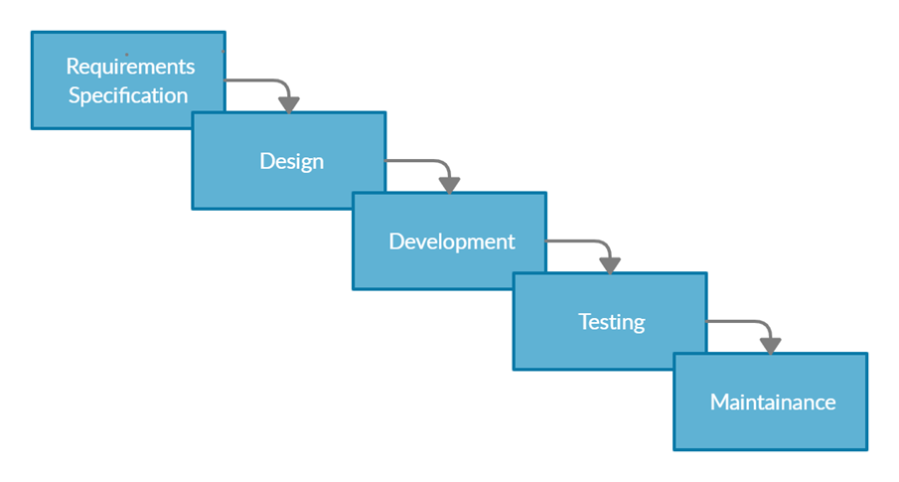

Architectural Diagram

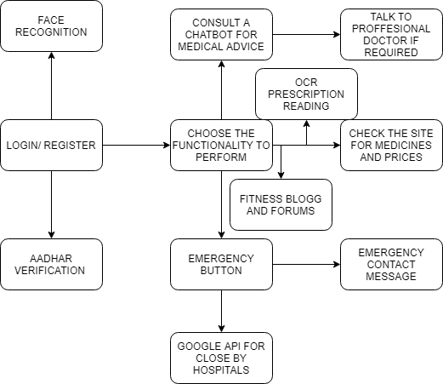

## Proposed System Model(UML Diagram)

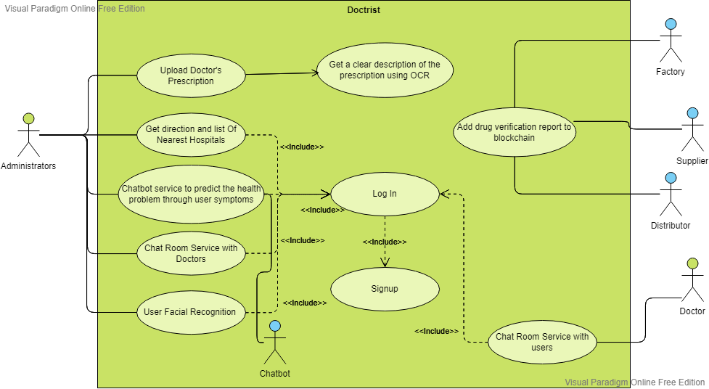

# Technical Specifications

## Introduction

When a user comes for the first time he/she has to login, the login module uses facial recognition library, here only 1 photo is required which is a plus point. In this module when the user registers on our website, they take a snapshot of theirs. This snapshot is stored in a folder named “data'' where the snapshots of all our users are stored. Now when a user has to login into his account, he goes to the login page. This photo is stored in the folder ‘temp’ and is matched with the photo in the ‘data’ folder. Next we have the Aadhar OCR. The user uploads their Aadhar card image and our system verifies the name and date of birth of the user from the Adhar card and the details provided. Next is chatbot and live chat. In this module, for chatbot, we have used chatterbot and for a live chat, we have used socket.io to talk directly with the doctor. In chatbot, we have trained our data for symptoms of 40,000 diseases and have with the details of 41 diseases in our chatbot and if the user is not happy with the results of the chatbot we are giving the option to chat with the doctor in which we have used socket.io for live chat with doctors. After these there is SMS being used to send notification for emergencies, web scraping and blockchain module, and at last is the hospital API.

## Requirement Analysis

### Functional Requirements

#### Product Perspective

Our product aims to give all kinds of possible services under one roof, making the whole process easy for the patient enabling him to get utmost care. Apart from the existing features of this product in future the patient can even set the dosage in the web app and it will remind them to have their medicine on time.

#### Product features

Our product is providing everything under one roof. Starting with our login module the facial recognition library being used by us only requires 1 photo whereas other products in the market require more than 100 photos per person to train the module properly, which is more of a traditional method.   
  
The aadhar OCR that we are using no such open source system exists. One of the most common competitors of our chatbot is rasa nlu, and even a few more traditional training based chatbots but the biggest problem with these is they are not useful for particular domain related work. Our chatbot allows the patient or its family member to talk and get a solution and if they aren’t satisfied they can even get to talk to a doctor and get the desired medication or cure.

The prescription OCR that has been made by us no such open source system exists. Incase of OCR we have used google vision API and we find our competitor to be pytesseract.  
Our main reason behind choosing google vision was its speed, google vision is much faster than pytesseract and its even much more accurate.Coming onto the part where scanning happens in case of pytesseract some of the unwanted elements are scanned whereas in case of google vision no more unwanted elements are recognized.

#### User characteristics

User is suffering from a medical condition and is in need of aid or the user is in need of medicines.

User is sick and needs to call an ambulance or wants to know the nearest hospital or medical facility that has available beds.

#### Assumption & Dependencies

Our assumption is that the proposed design will be working seamlessly with different operating systems and all the mobile gadgets.

#### Domain Requirements

* Domain Name
* Simple User interface
* Simple Design

#### User Requirements

* Accessibility
* Flexibility
* Speed
* Smooth user experience
* Seem less transactions

### Non Functional Requirements

#### Product Requirements

* Secure user’s data
* System properties

##### Efficiency (in terms of Time and Space)

The proposed system takes around 15MB space and works fine with 2GB Ram devices.

##### Reliability

The proposed design is very simple in that it hardly crashes and less traffic in most cases.

##### Portability

The system is highly portable and is not dependent on any operating system or any device or web browser. It can be accessed by any device with an internet connection to open the web interface through a website link.

##### Usability

The model is very easy to use for any person with minimal knowledge of how to surf any website

#### Organizational Requirements

##### Implementation Requirements (in terms of deployment)

The models are converted into appropriate APIs using Flask and these APIs are then deployed. The developed web interface will be hosted on our personal domain. The deployed APIs will be used and called by the web interface to build a link between the user inputs and the models for the possible disease prediction.

##### Engineering Standard Requirements

The software is developed using all necessary standards specified by the ISO and IEEE.

#### Operational Requirements (Explain the applicability for your work w.r.to the following operational requirement(s))

* Economic

The developed software involves no economic operational requirements

* Environmental

The developed software involves no harmful effect on the natural environment, induced and/or self-induced environmental effects, and threats to the societal environment.

* Social

The developed software collects the user information to help to understand their current symptoms and to save identity, the data is kept confidential and not shared with anyone

* Political

The developed software involves no political operational requirements

* Ethical

The developed software adheres to the human ethical and moral values and does not intend to harm anyone socially, politically or economically

* Health and Safety

The developed software does not pose harm to the health and safety of any living being. All necessary standards and measures are being taken care of.

* Sustainability

The developed software is made to have a sustainable impact on society.

* Legality

The developed software adheres to all legal requirements, rules and laws and is an original creation by the developers. It doesn't intend to claim anyone else’s copyrights or patents.

* Inspectability

The developed software involves no inspectability operational requirements

### System Requirements

#### H/W Requirements(details about Application Specific Hardware)

A hardware device like laptop/computer/mobile/tablet etc. to access the web application.

#### S/W Requirements(details about Application Specific Software)

Web Browser: Internet Explorer, Chrome, Firefox and Safari with enabled JavaScript support.

# Design Approach and Details

## Design Approach/Materials & Methods

**Login**:

Modules used are Facial Recognition library (only requires 1 photo). Competitor: Traditional training methods (requires more than 100 photos to train per person) In this module when the user registers on our website, they take a snapshot of theirs. This snapshot is stored in a folder named “data” where the snapshots of all our users are stored. Now when a user has to login into his account, he goes to the login page. There he is asked to take a snapshot of his face. This snapshot is stored in a folder ”temp”. Now the program runs the face recognition function and takes images of all the people who registered from the data folder and performs face encoding on each and stores it in an array.

Then it takes the image in the temp folder and compares the image to each image in the data folder and finds the distance between them. It stores the distance in another array. It sorts the array and finds the image with the minimum distance. If the distance is above a threshold it returns the name of the user of whose image it is. If the username matches for the user who is attempting to log in, it allows the person to complete the login and move into his account, else asks the person to try again or use the password.

**Aadhar OCR**: In this module, the user uploads their Aadhar card image and our system verifies the name and date of birth of the user from the Adhar card and the details provided.

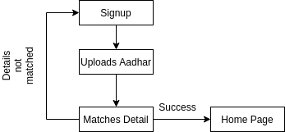  
 Fig :- Workflow of Aadhar OCR

For detecting text, we have used Google-Vision API from Aadhar Card. For finding Aadhar card we are using a regular expression to search for 12 digits number, for detection of the father’s name we are searching for the keywords “C/O" or “D/O” or “S/O” as in Aadhar card the father’s name appears after that, for detection of address we are selecting all the index from father’s name till we find the PIN CODE which can be found by searching 6 digit number, for date of birth we are searching the particular format of the date that is present in Aadhar card like (dd/mm/yyyy).

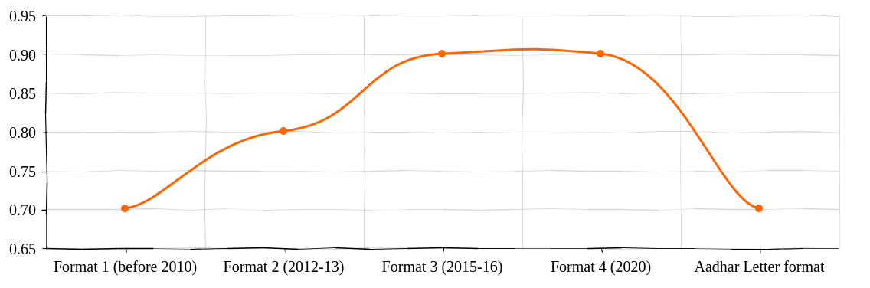

Fig : - Accuracy vs Aadhar Format

**Chatbot and Live Chat: :** In this module, for chatbot, we have used chatterbot and for a live chat, we have used socket.io to talk directly with the doctor.

In chatbot, we have trained our data for symptoms of 40,000 diseases and have with the details of 41 diseases in our chatbot and if the user is not happy with the results of the chatbot we are giving the option to chat with the doctor in which we have used socket.io for live chat with doctors.  
  
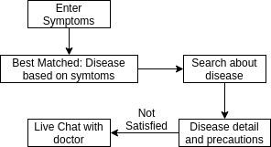

Fig :- LiveChat and chatbot workflow

**SMS:**

We are using this module to send SMS to the registered mobile numbers of users to inform them about any emergencies or information regarding their health.

We are using the Twilio API to do so.

**Web Scraping:**

This module is being used to scrape data off a website to gather the information required to create a database. Over here we are scraping the name of the medicine and its price in the Indian market to create a database for all the medicines present in India. This database would then be used to create the e-commerce part of our project. Modules used here are requests and BeautifulSoup.

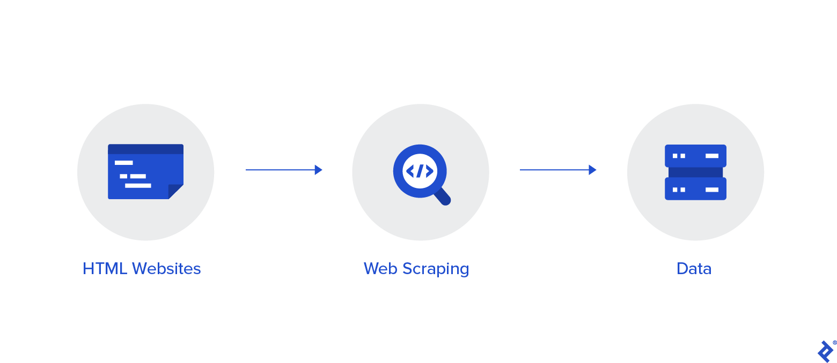

First, we open and read the website present and check for all the data that is required. We then check the source code. In the source code, we check the data that is required and the HTML tags they are present in. Then using those tags we extract the required data.

**Blockchain:**

This module will help us to detect whether the medicines that we are getting are original or not, i.e, whether they are fake or expired and have been restamped.

The value of this module represents: Fighting Drug Forgery, Data Integrity, Enhanced Traceability and Elevated compliance regulatory.

The procedure that ensues for drug traceability would be as followed:

1] The manufacturer marks the produced drug with a unique code and a hash is produced. This information is stored on the blockchain.

2] These drugs are then sent to the wholesaler

3] The drug is then verified by the manufacturers and this transaction is further stored in the blockchain.

4] The wholesaler sends the drugs to the pharmacist.

5] Further verification is carried out and this transaction is also stored in the blockchain.

6] From the pharmacist the drugs are then delivered to the patients.

7] The patient also verifies the origin of the drug and this transaction would also be stored in the blockchain.

**Hospital API:**

This API fetches data of Hospitals from different cities of India.

This API displays data like Id, State, City, Name, Category, Medicine, Address, Website, Specialization. We have developed a Django Rest API for getting the list of hospitals and we have taken the data from data.gov.in which is an Indian government data website. This API fetches data like city, state name of the hospital, medicine type, address, website and specialization of the hospital. This API can find both the categories, private as well as public/ government hospitals. We have created an HTML form that takes the city name as an input and uses it as a search parameter to find the hospital. We display the data in tabular form.

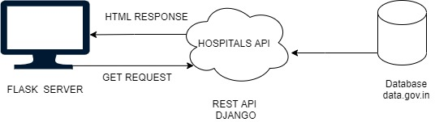

## Codes and Standards

1. Indentation - Proper Indentation is maintained at the beginning and at the end of each block in the program.

2. Meaningful and understandable variable names are used so that it helps anyone to understand the reason for using it.

3. Limited use of global variables in the code

4. Proper error handling and exception handling is done in the program

5. Easy to understand code style is used in the project

# Schedule ,Tasks and Milestones

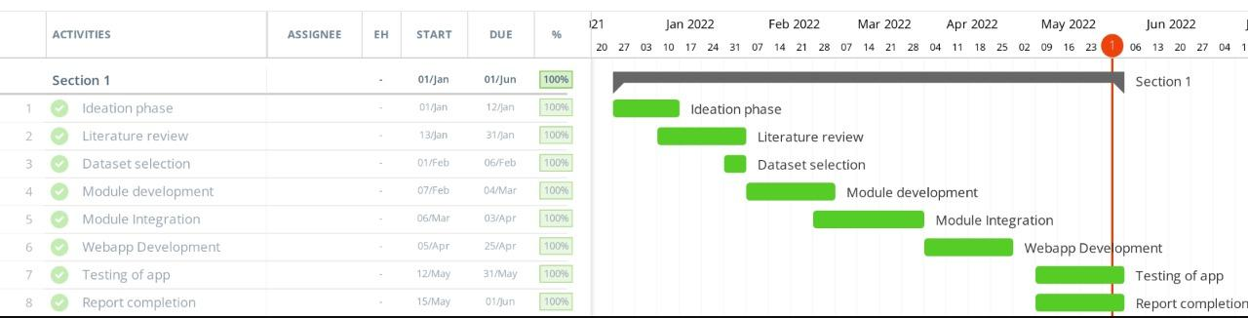

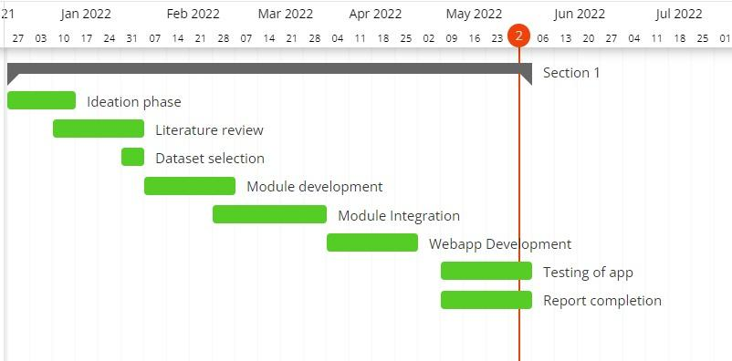

# Project Demonstration

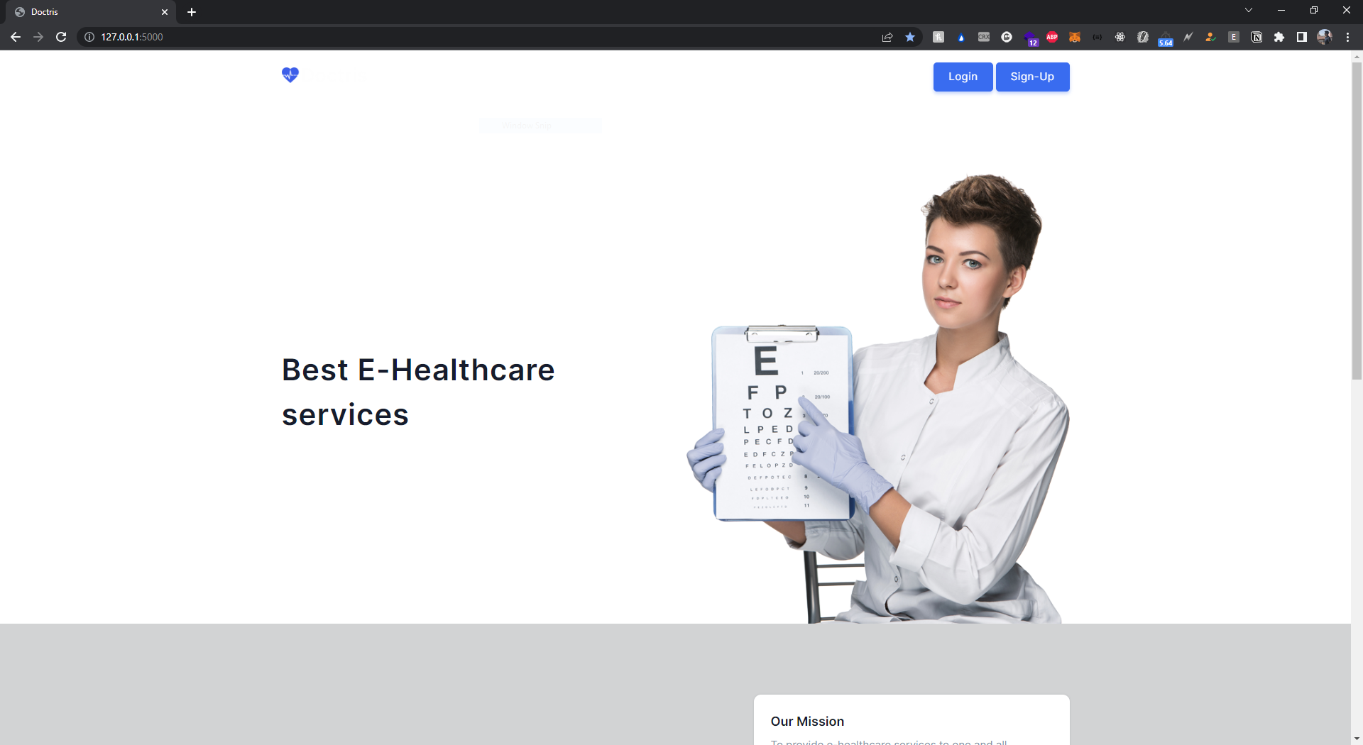

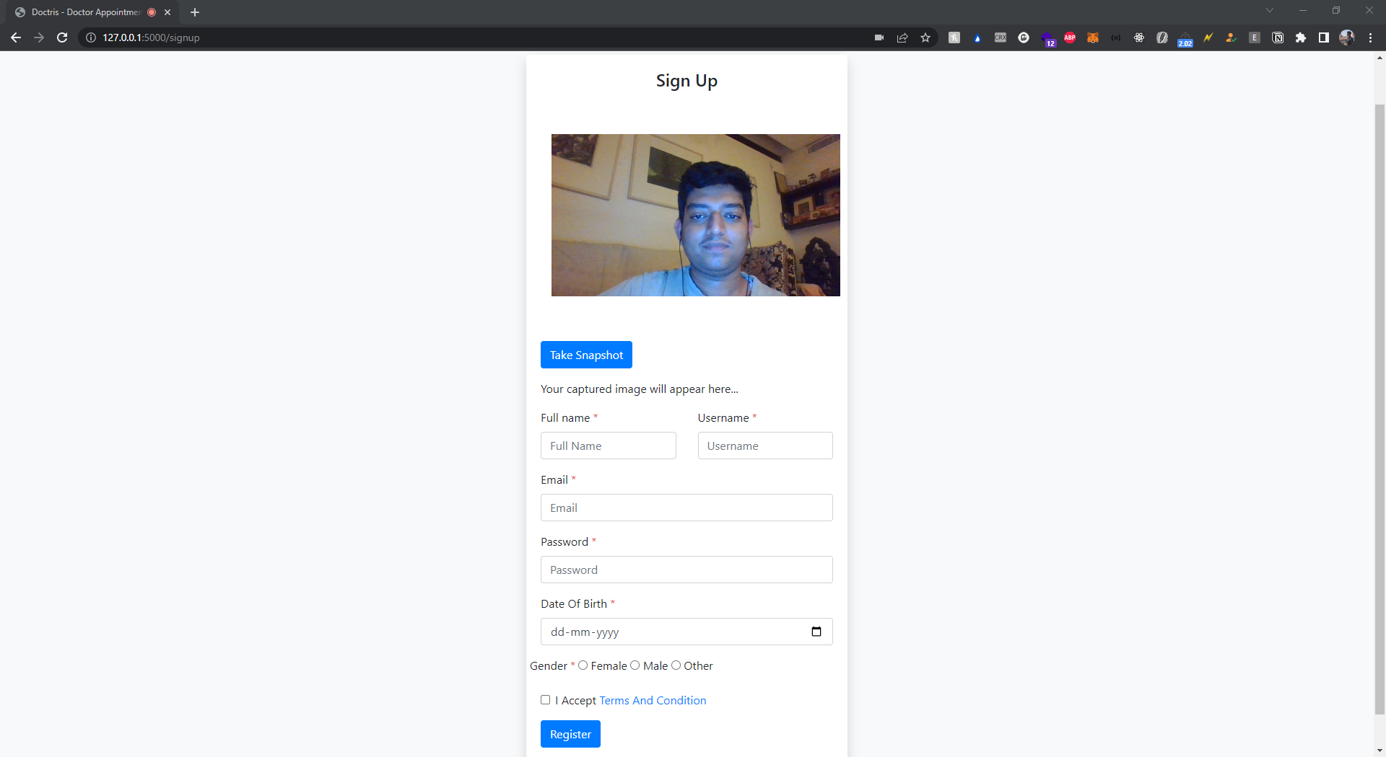

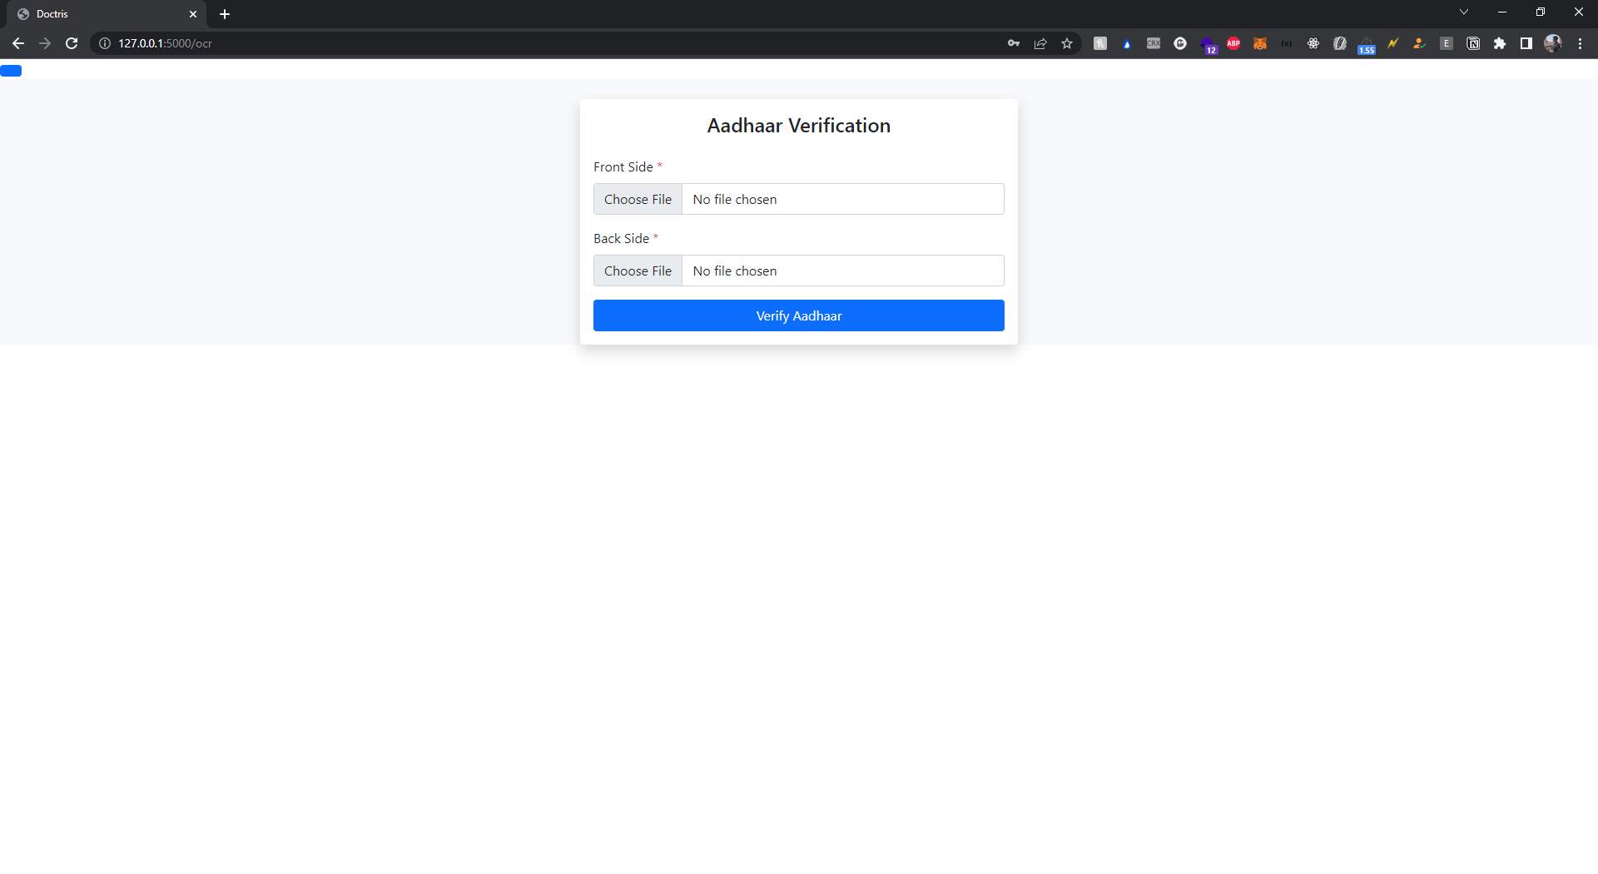

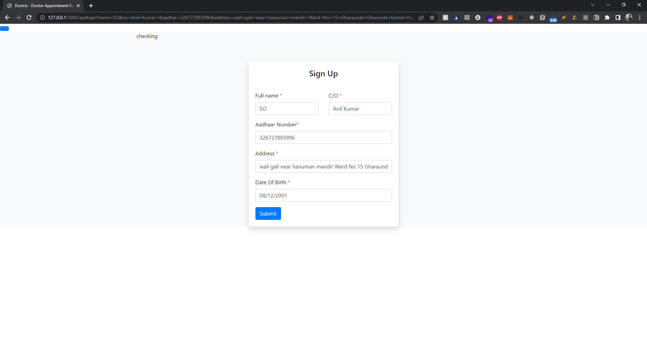

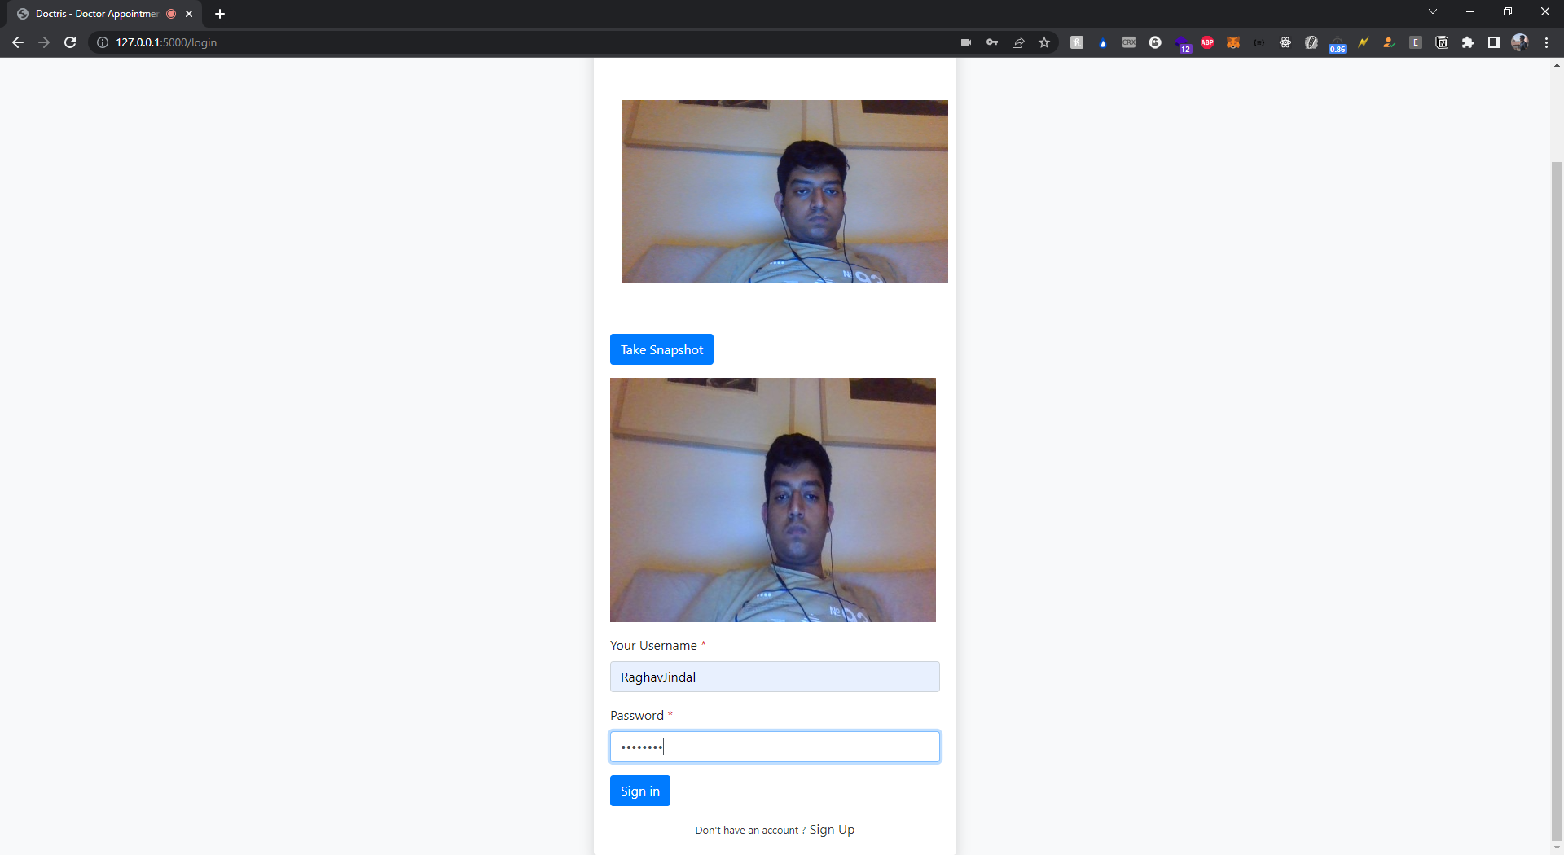

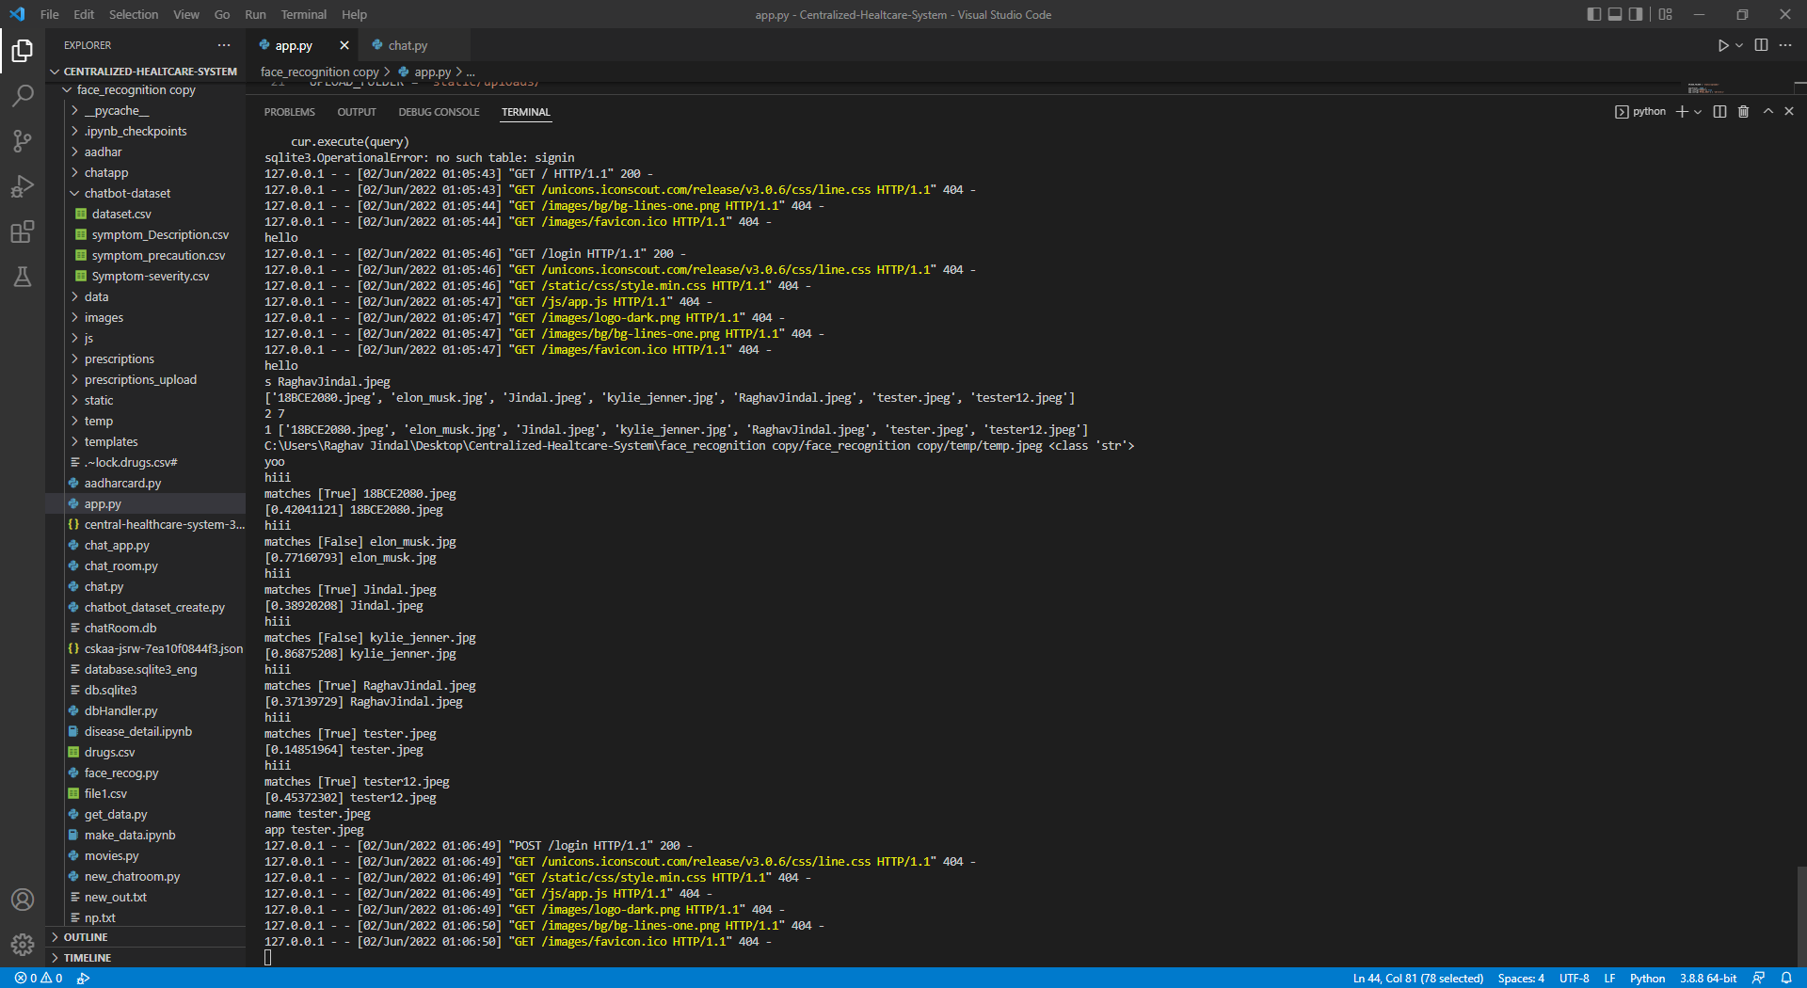

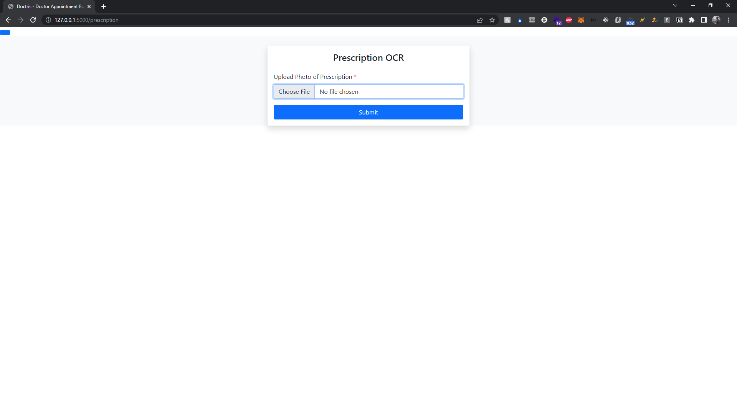

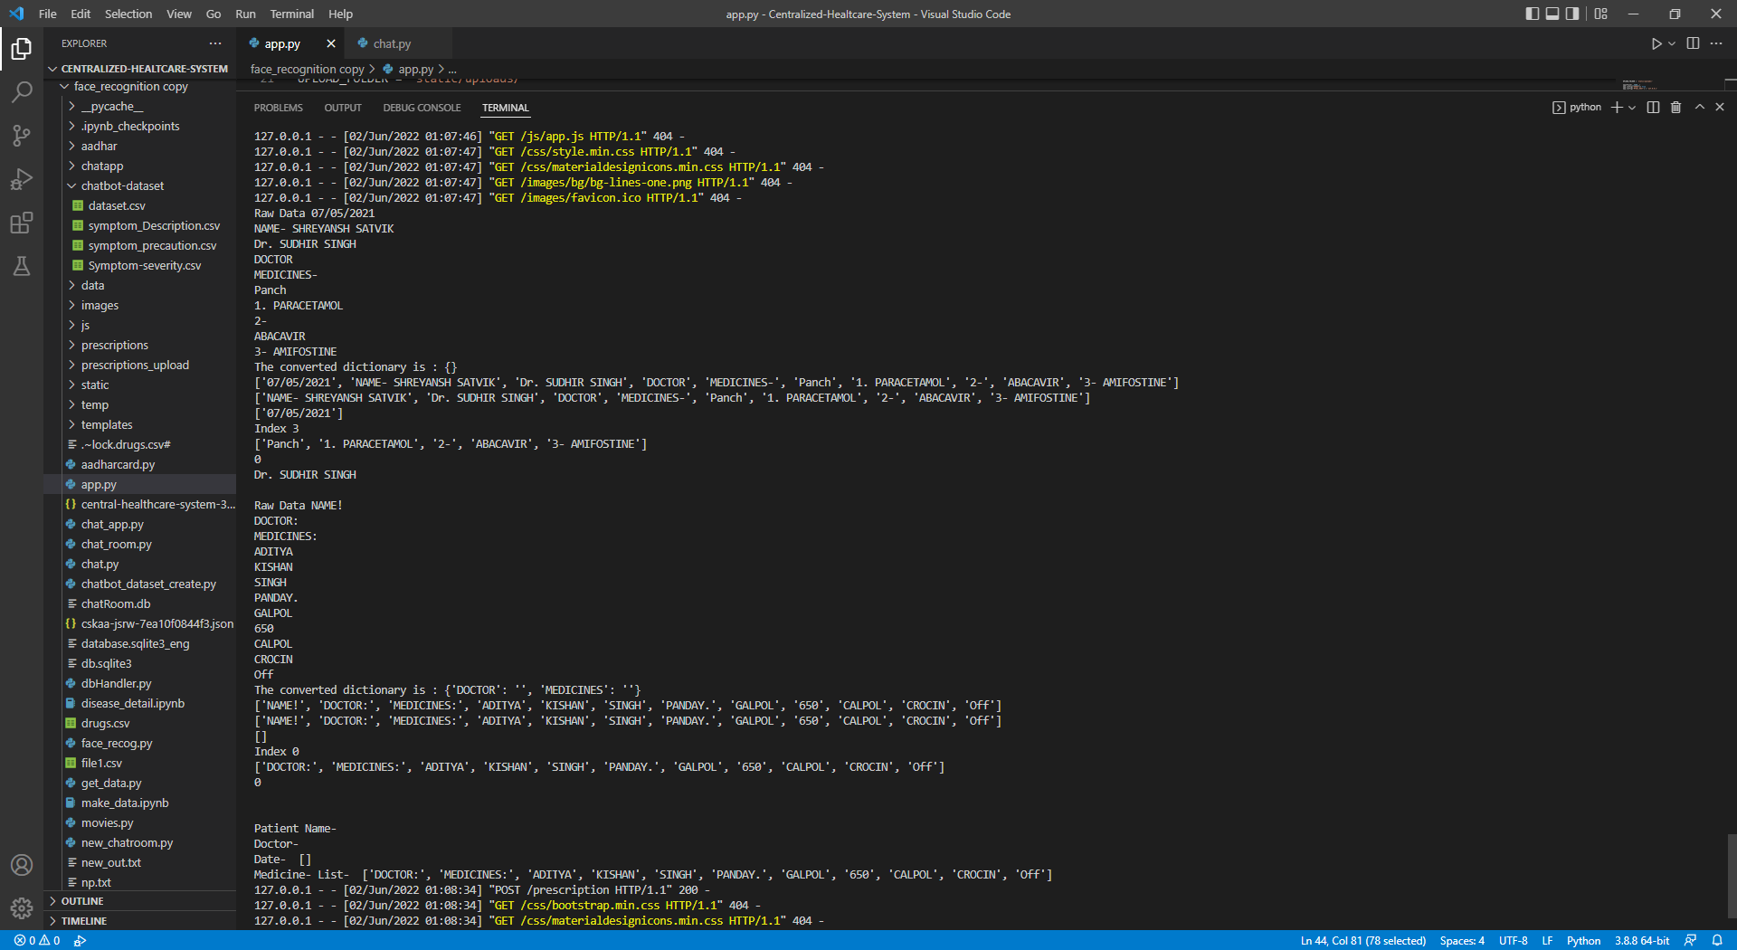

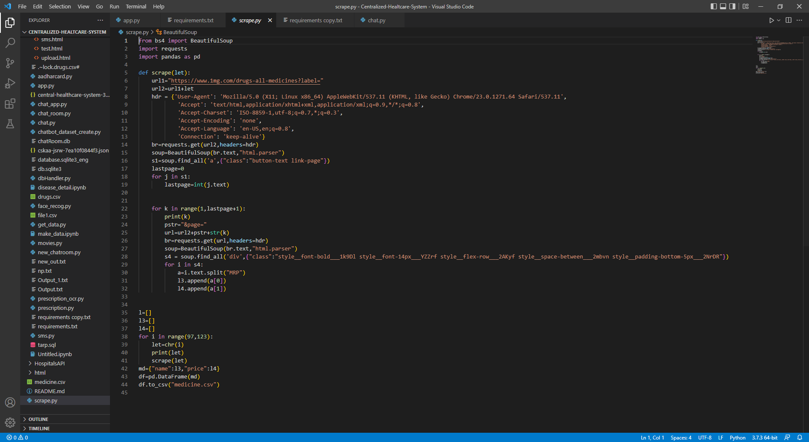

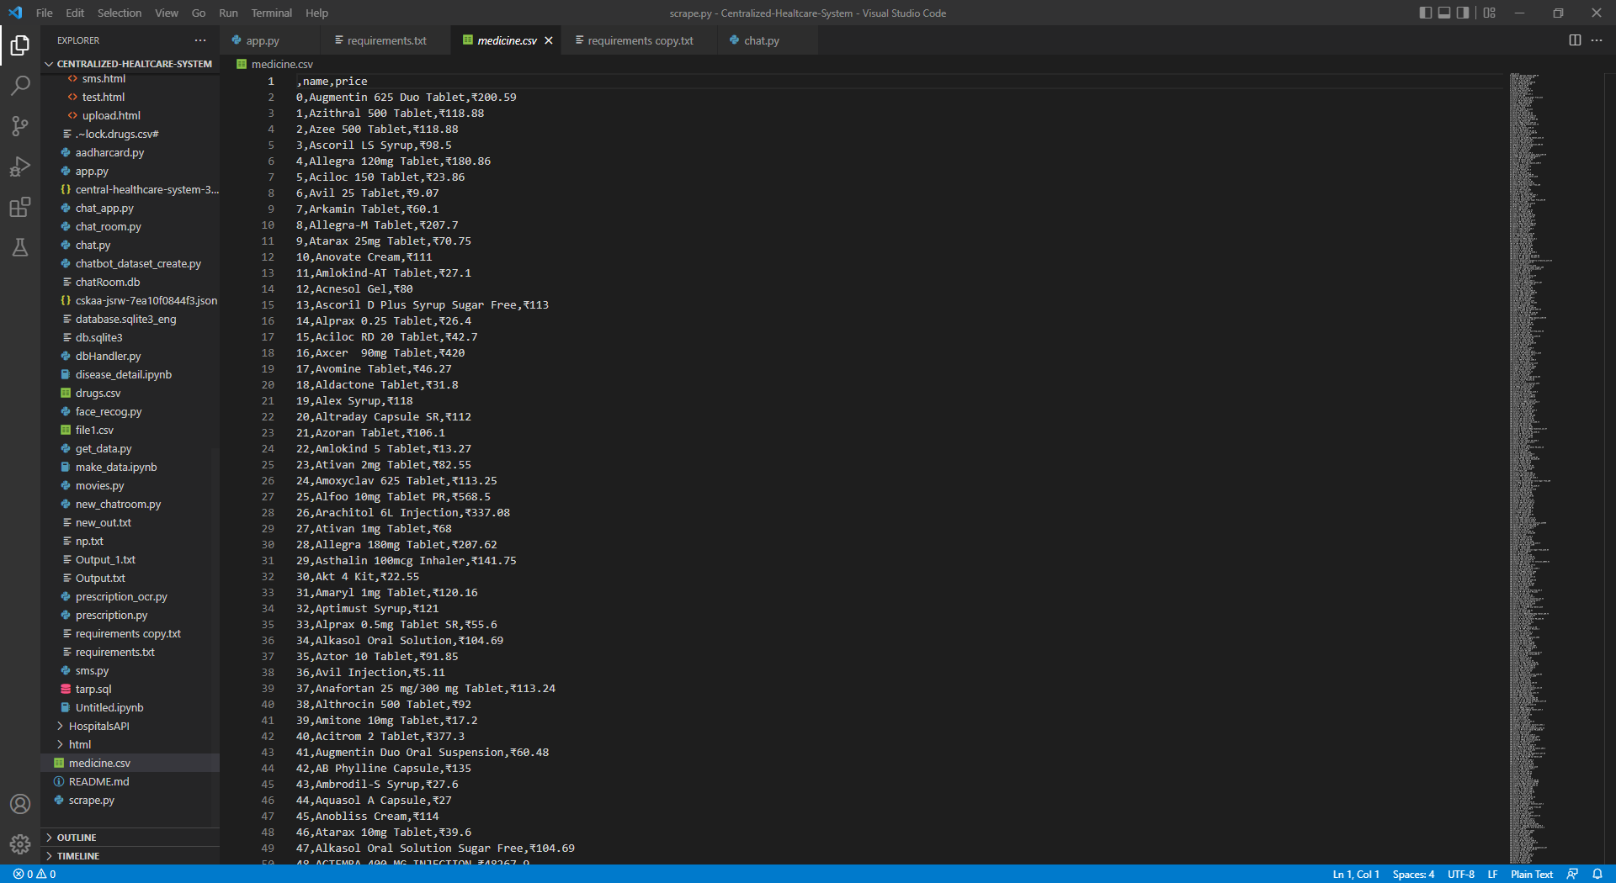

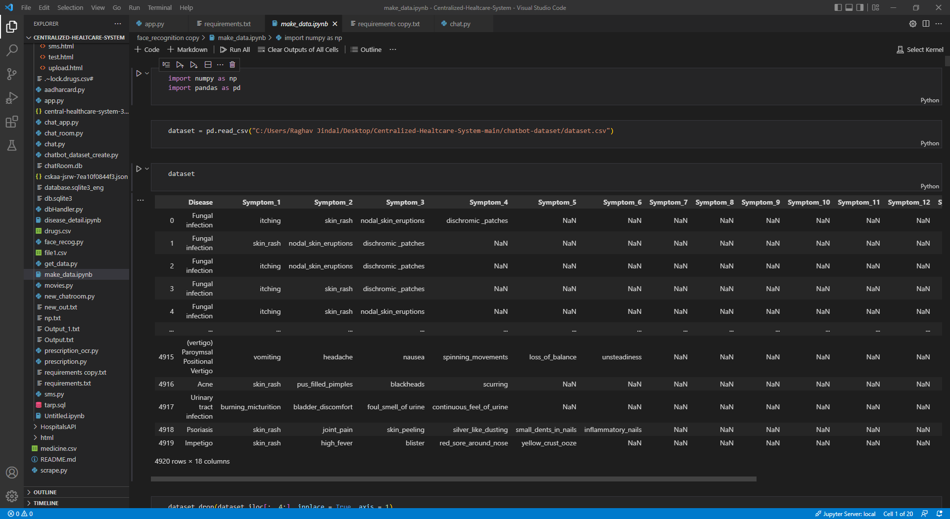

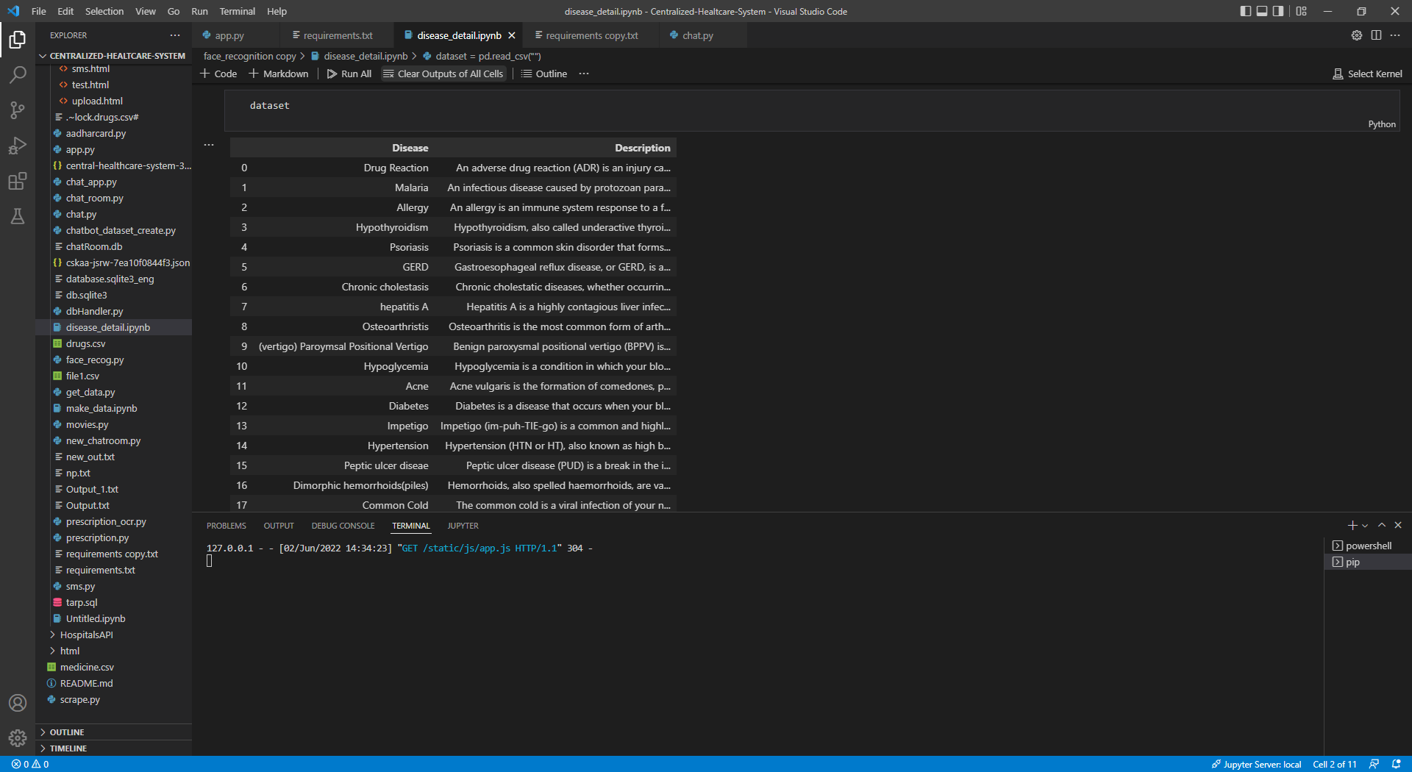

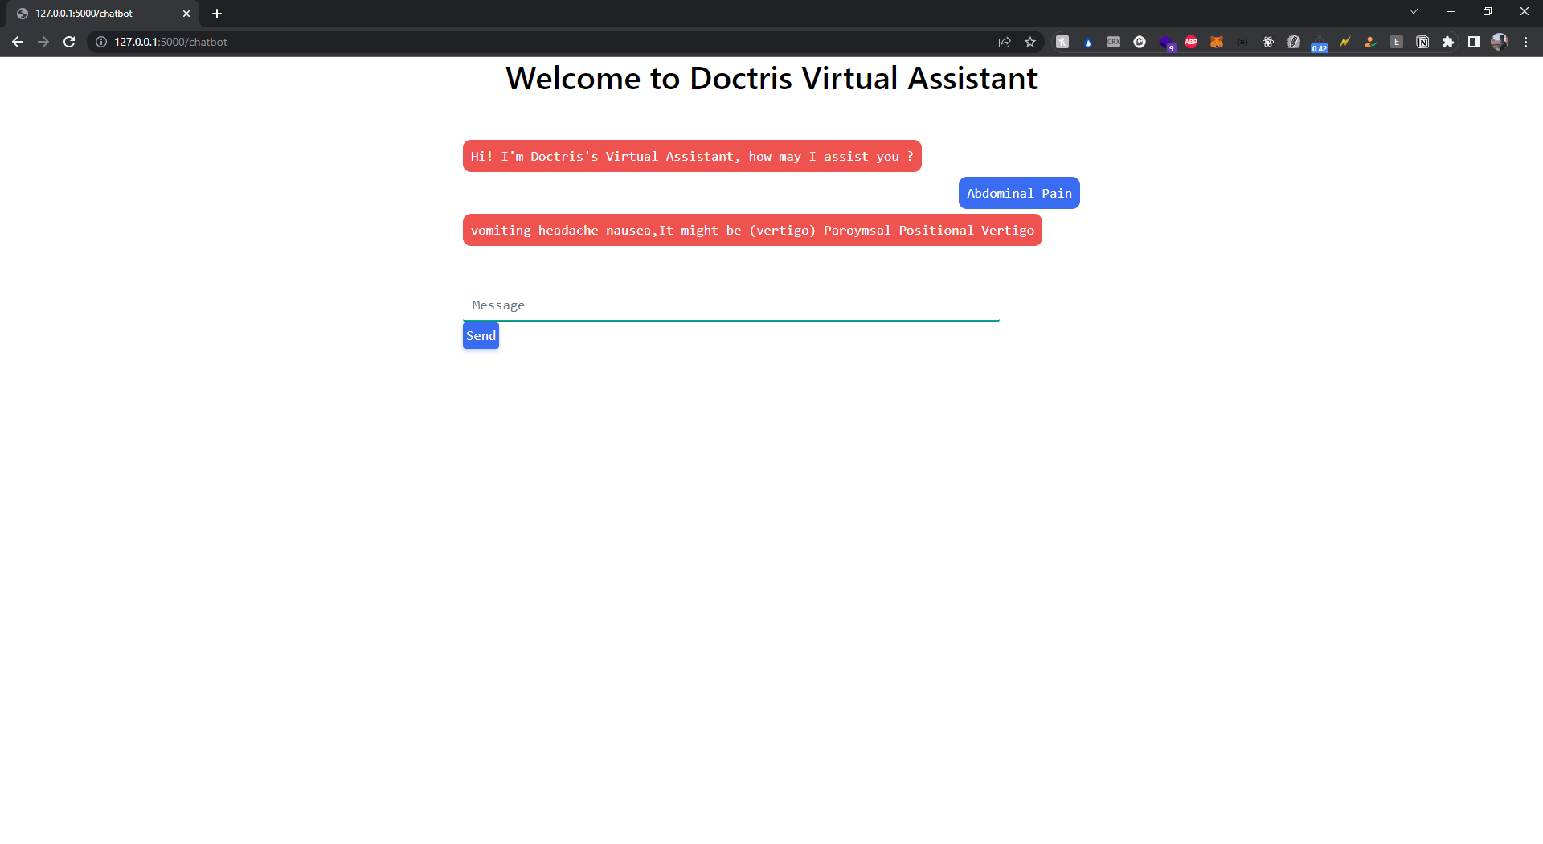

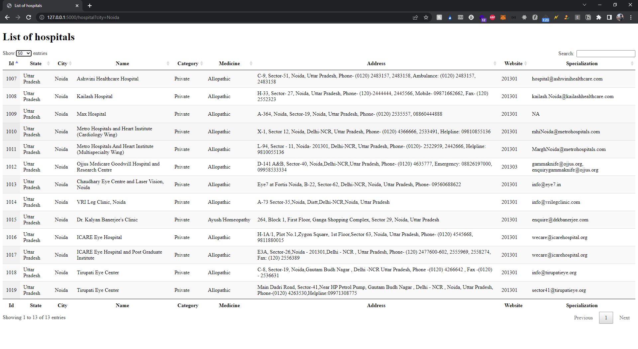

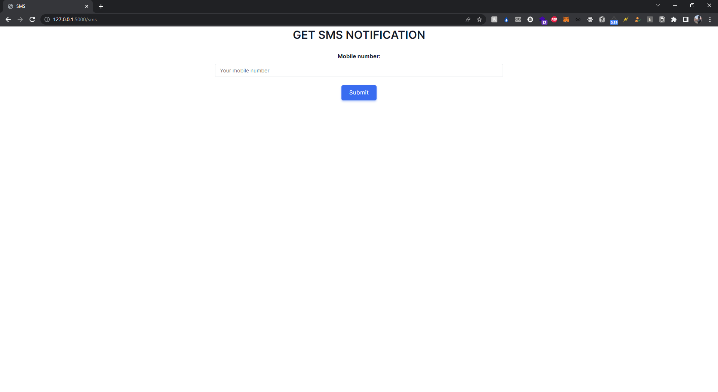

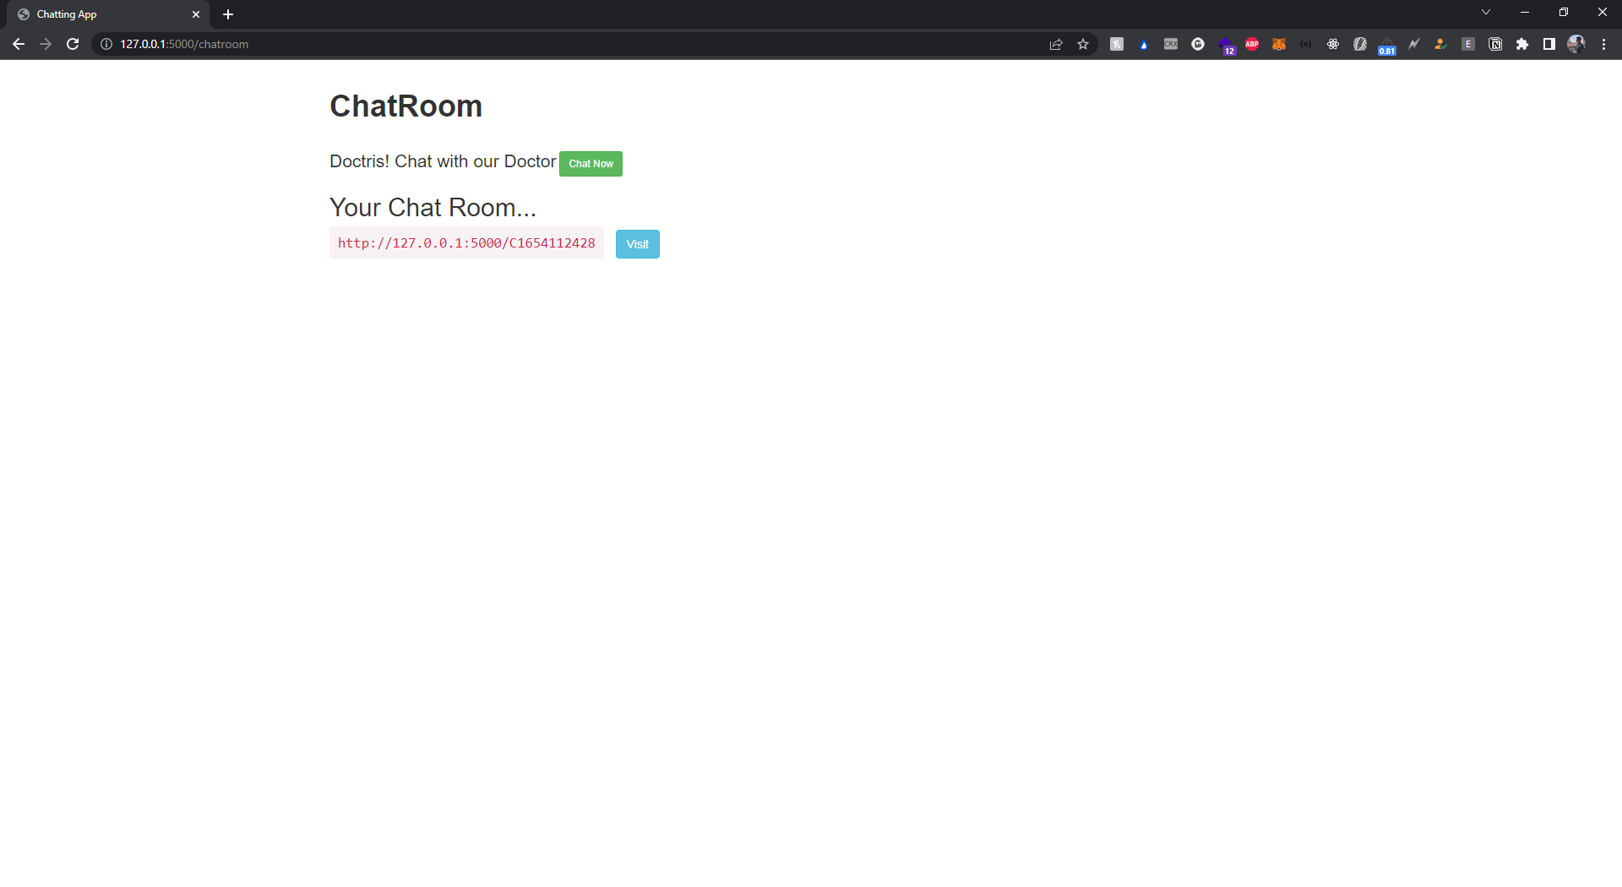

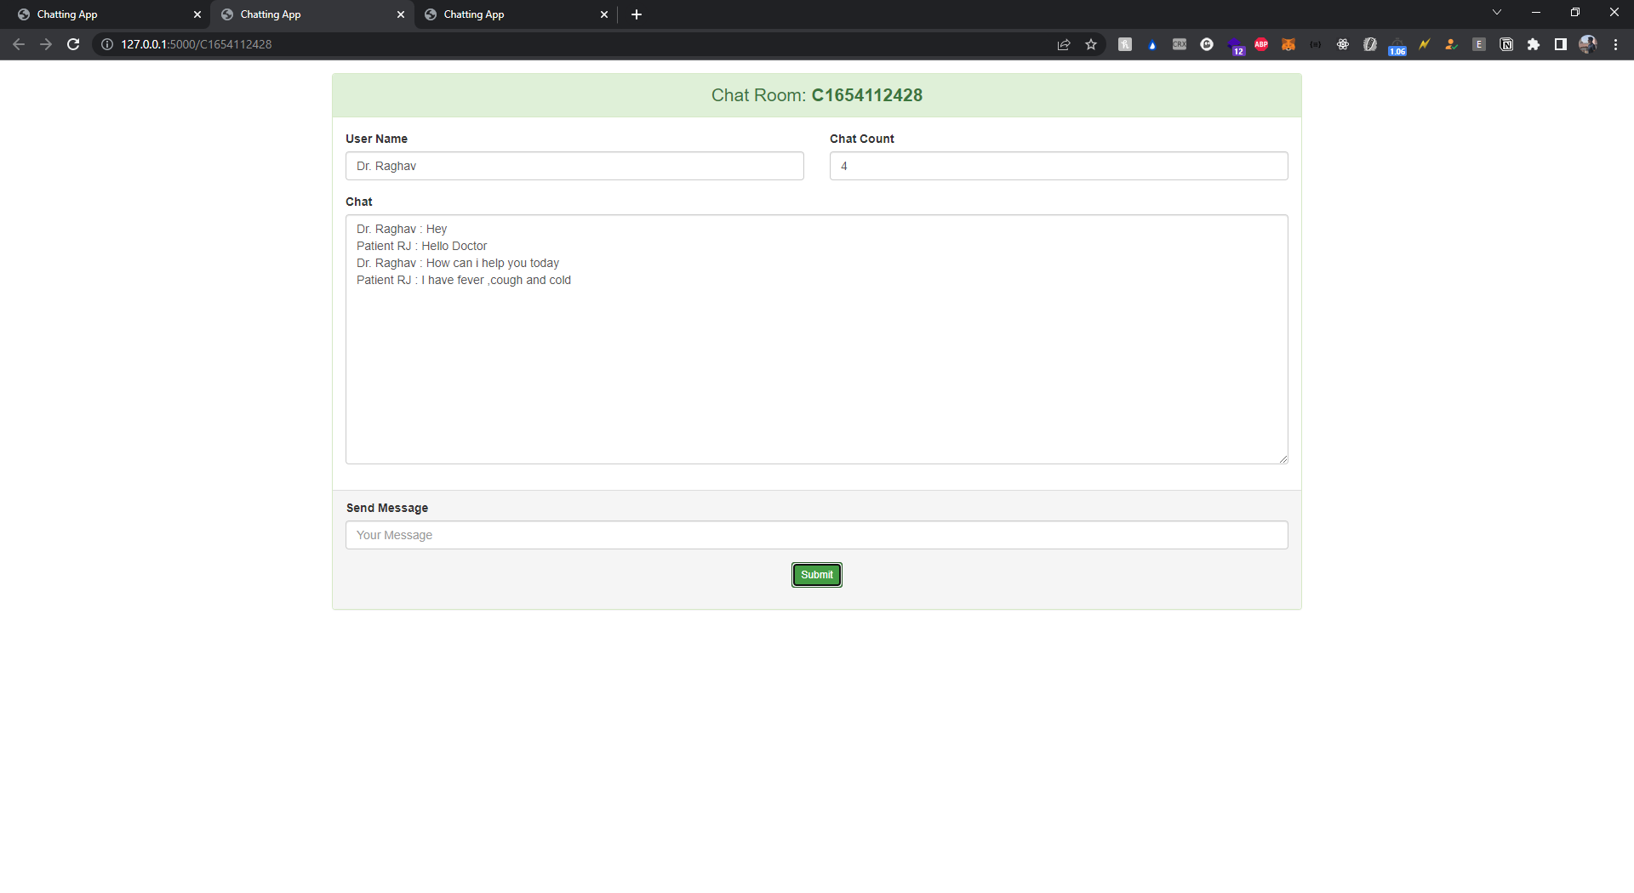

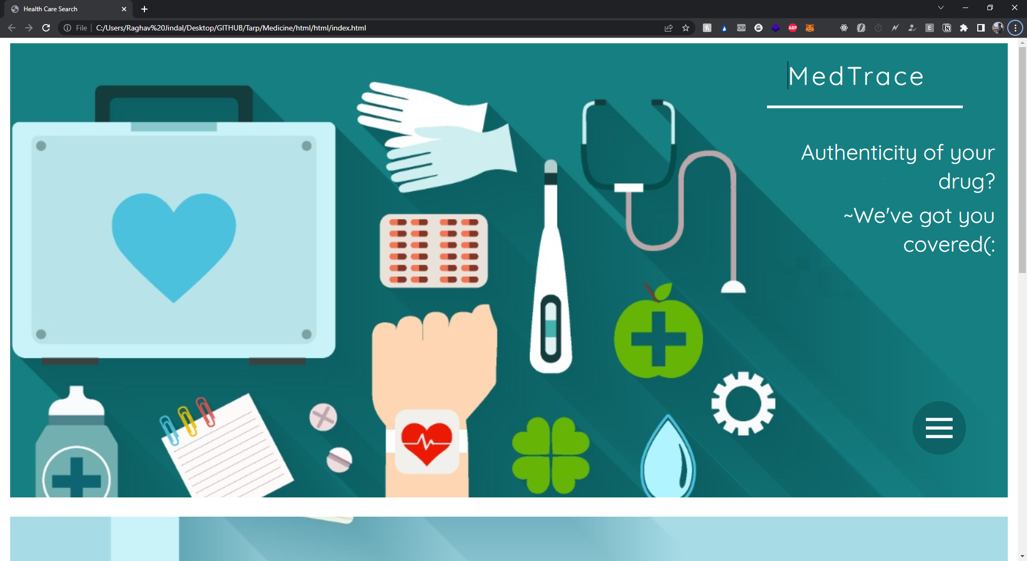

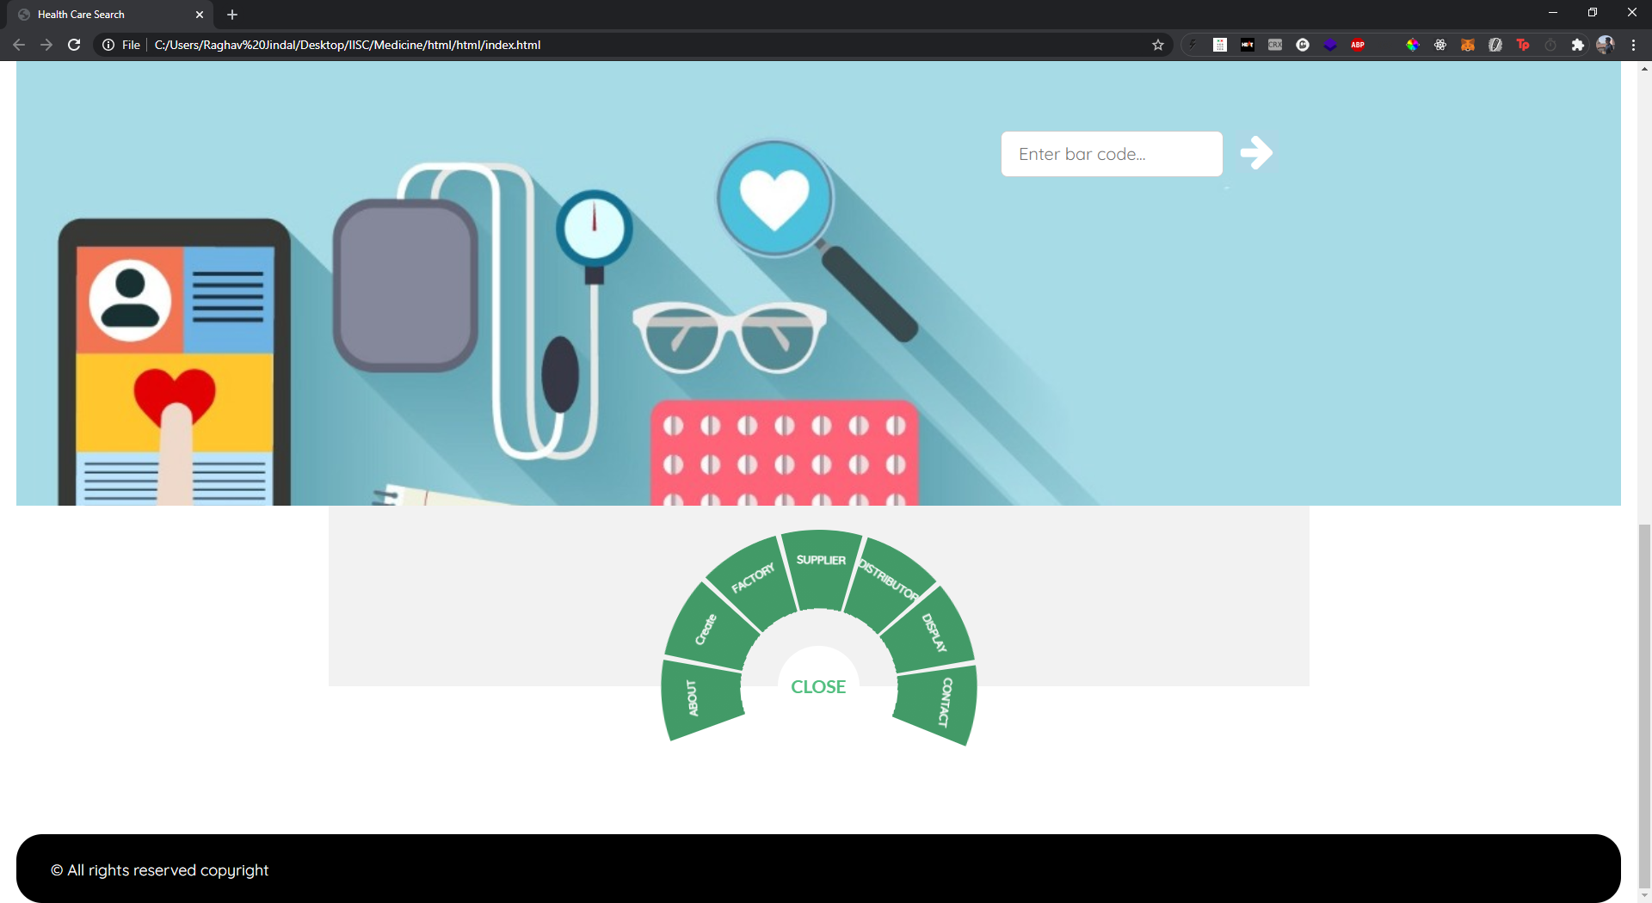

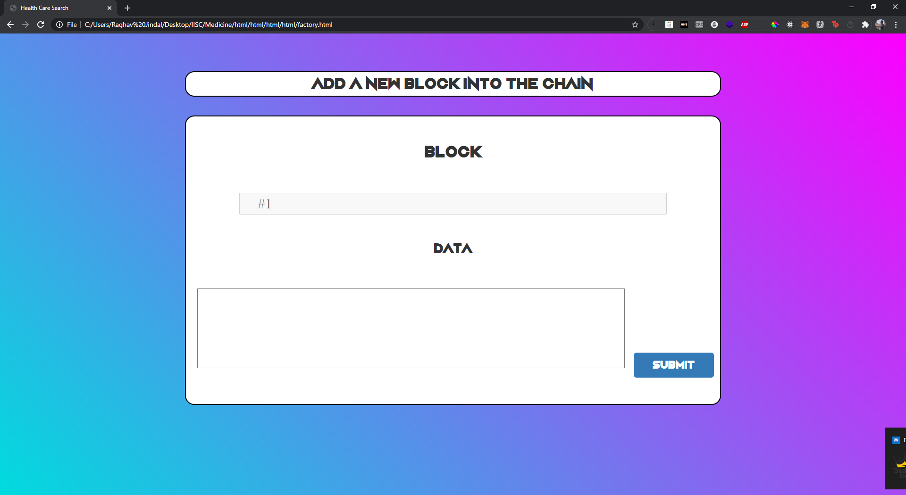

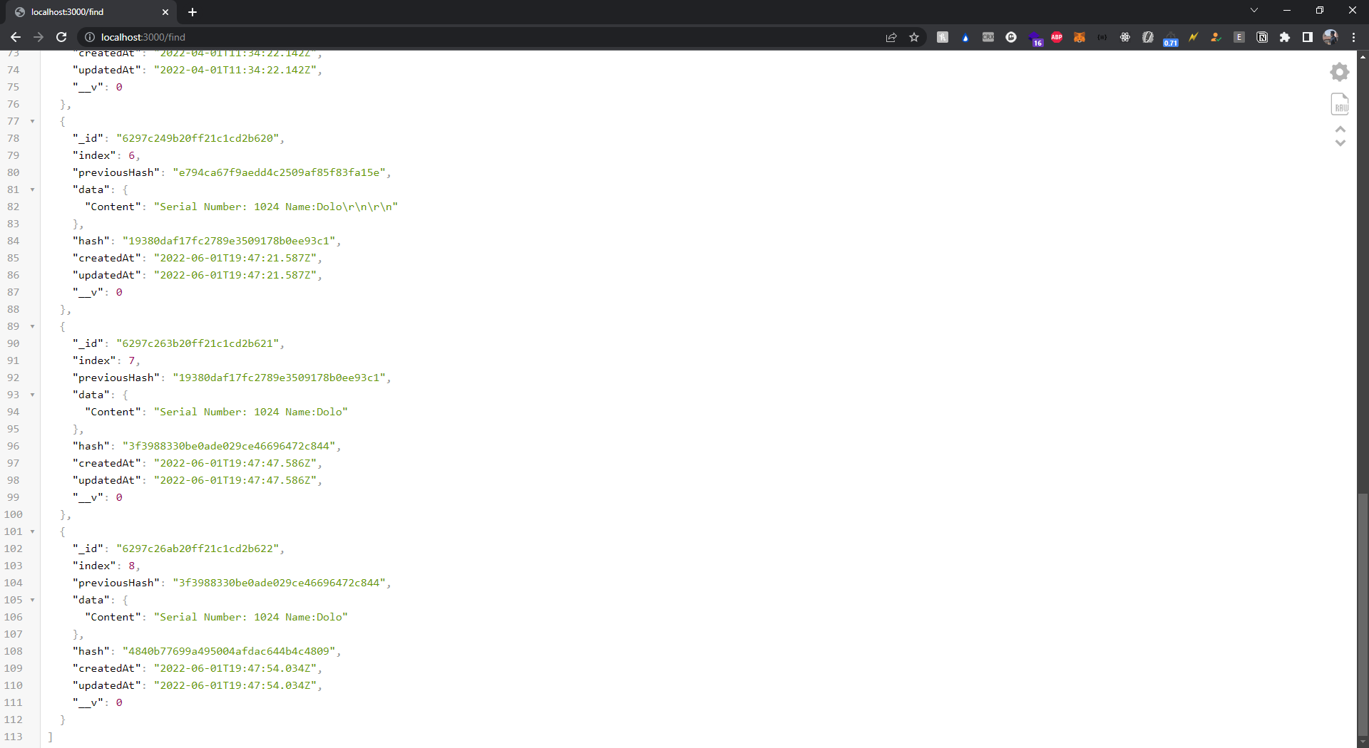

# Results

We come across the following results with the help of the modules in order to successfully run this project. Under the Aadhar OCR, once the user attempts to signs up with certain details such as user name, email ID, Date Of Birth etc, these details are then further matched with the information available on their Aadhar card. If it matches, then the user is able to sign up. The prescription OCR enables users to scan their own prescriptions to find their medicines online and also look out for their substitutes based on the salt composition of the prescribed medication. This will help them find out the alternatives of their medication in case of unavailability of their prescribed medicines. The chatbot is set up with a trained data strength of 40,000 symptoms. It is able to respond accurately to the 41 diseases it has been trained in. The ambulance button enables the user to send their live location to the driver who can access and reach the user’s location easily. Blockchain helps us in preventing drug forgery by verifying the source and origin of the drugs and whether they are suitable for consumption.

# Summary

Our product is providing everything under one roof. There are many products in the market providing most of our services but individually or with lesser or complex features. Starting with our login module the facial recognition library being used by us only requires 1 photo whereas other products in the market require more than 100 photos per person to train the module properly, which is more of a traditional method.   
  
The aadhar OCR that we are using no such open source system exists. One of the most common competitors of our chatbot is rasa nlu, and even a few more traditional training based chatbots but the biggest problem with these is they are not useful for particular domain related work. Our chatbot allows the patient or its family member to talk and get a solution and if they aren’t satisfied they can even get to talk to a doctor and get the desired medication or cure.

The prescription OCR that has been made by us no such open source system exists. Incase of OCR we have used google vision API and we find our competitor to be pytesseract.  
Our main reason behind choosing google vision was its speed, google vision is much faster than pytesseract and its even much more accurate.Coming onto the part where scanning happens in case of pytesseract some of the unwanted elements are scanned whereas in case of google vision no more unwanted elements are recognized.

# 

# 

# References

1. Islam, Noman & Islam, Zeeshan & Noor, Nazia. (2018). A Survey on Optical Character Recognition System. ITB Journal of Information and Communication Technology.
2. Hamad, Karez & Kaya, Mehmet. (2018). A Detailed Analysis of Optical Character Recognition Technology. International Journal of Applied Mathematics, Electronics and Computers. 4. 244-244. 10.18100/ijamec.270374.
3. A. Alamri, "Monitoring System for Patients Using Multimedia for Smart Healthcare," in IEEE Access, vol. 6, pp. 23271-23276, 2018, doi: 10.1109/ACCESS.2018.2826525.
4. Information Extraction From Images Using Pytesseract and NLTK", International Journal of Emerging Technologies and Innovative Research (www.jetir.org), ISSN:2349-5162, Vol.4, Issue 5, page no.83-84,May-2018
5. Patel, Chirag & Patel, Atul & Patel, Dharmendra. (2018). Optical Character Recognition by Open source OCR Tool Tesseract: A Case Study. International Journal of Computer Applications. 55. 50-56. 10.5120/8794-2784.
6. Kelechi, Oketa & Alo, Uzoma & Henry, Okemiri & Nneka, Richard-Nnabu & Ifeanyi, Achi & I., Chinazo & Idris, Afolabi & Praise, Mgbanya. (2019). Computerized Drug Verification System: A Panacea for Effective Drug Verification. International Journal of Advanced Computer Science and Applications. 10. 10.14569/IJACSA.2019.0101115.
7. Chang, Shuchih Ernest & Chen, Yi-Chian. (2020). Blockchain in Health Care Innovation: Literature Review and Case Study From a Business Ecosystem Perspective (Preprint). 10.2196/preprints.19480.
8. Raffel, Colin & Shazeer, Noam & Roberts, Adam & Lee, Katherine & Narang, Sharan & Matena, Michael & Zhou, Yanqi & Li, Wei & Liu, Peter. (2019). Exploring the Limits of Transfer Learning with a Unified Text-to-Text Transformer.
9. Sylim, Patrick & Liu, Fang & Marcelo, Alvin & Fontelo, Paul. (2018). Blockchain Technology for Detecting Falsified and Substandard Drugs in the Pharmaceuticals Distribution System (Preprint). JMIR Research Protocols. 7. 10.2196/10163.
10. Devlin, J.; Chang, M.-W.; Lee, K. & Toutanova, K. (2018), 'BERT: Pre-training of Deep Bidirectional Transformers for Language Understanding' , cite arxiv:1810.04805Comment: 13 pages .
11. C. Szegedy, V. Vanhoucke, S. Ioffe, J. Shlens and Z. Wojna, "Rethinking the Inception Architecture for Computer Vision," 2016 IEEE Conference on Computer Vision and Pattern Recognition (CVPR), Las Vegas, NV, USA, 2016, pp. 2818-2826, doi: 10.1109/CVPR.2016.308.
12. Zhao, Bo. (2017). Web Scraping. 10.1007/978-3-319-32001-4_483-1.
13. Anushree Tandon, Amandeep Dhir, A.K.M. Najmul Islam, Matti Mäntymäki, Blockchain in healthcare: A systematic literature review, synthesizing framework and future research agenda,Computers in Industry,Volume 122,2020,103290,ISSN 0166-3615,
14. Galassi, Andrea & Lippi, Marco & Torroni, Paolo. (2019). Attention in Natural Language Processing.
15. Angraal, Suveen & Krumholz, Harlan & Schulz, Wade. (2018). Blockchain Technology: Applications in Health Care. Circulation: Cardiovascular Quality and Outcomes. 10. e003800. 10.1161/CIRCOUTCOMES.117.003800.
16. Rarhi, Krishnendu & Bhattacharya, Abhishek & Mishra, Abhishek & Mandal, Krishnasis. (2018). Automated Medical Chatbot. SSRN Electronic Journal. 10.2139/ssrn.3090881.
17. Wiens, Jenna & Shenoy, Erica. (2018). Machine Learning for Healthcare: On the Verge of a Major Shift in Healthcare Epidemiology. Clinical infectious diseases : an official publication of the Infectious Diseases Society of America. 66. 10.1093/cid/cix731.
18. Dhyani, Manyu & Kumar, Rajiv. (2020). An intelligent Chatbot using deep learning with Bidirectional RNN and attention model. Materials Today: Proceedings. 34. 10.1016/j.matpr.2020.05.450.
19. Damodharan, P. & C S, Ravichandran. (2019). Applicability Evaluation of Web Mining in Healthcare E-Commerce towards Business Success and a derived Cournot Model. Journal of Medical Systems. 43. 10.1007/s10916-019-1395-1.
20. A. F. S. Moura, S. S. L. Pereira, M. W. L. Moreira and J. J. P. C. Rodrigues, "Video Monitoring System using Facial Recognition: A Facenet-based Approach," *GLOBECOM 2020 - 2020 IEEE Global Communications Conference*, Taipei, Taiwan, 2020, pp. 1-6, doi: 10.1109/GLOBECOM42002.2020.9348216.

# Appendix

Below is the research paper published by our team for our project “Central Healthcare System”.

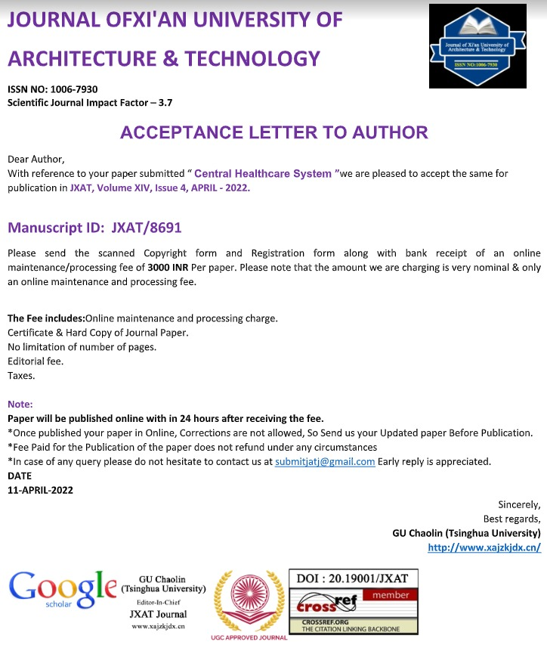

Journal in which research paper has been published

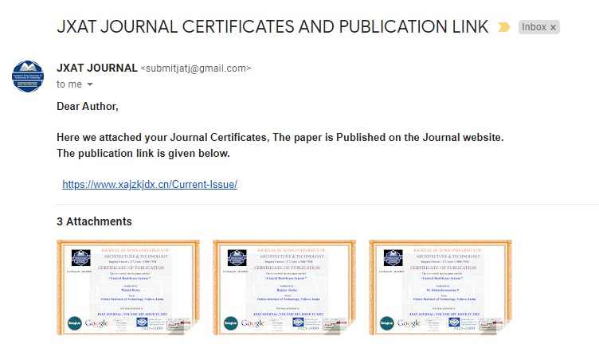

**PUBLICATION LINK :**

<https://www.xajzkjdx.cn/Vol-14-Issue-4-2022/>

#### 